**Hierarchical Task Analysis (HTA) Diagram**

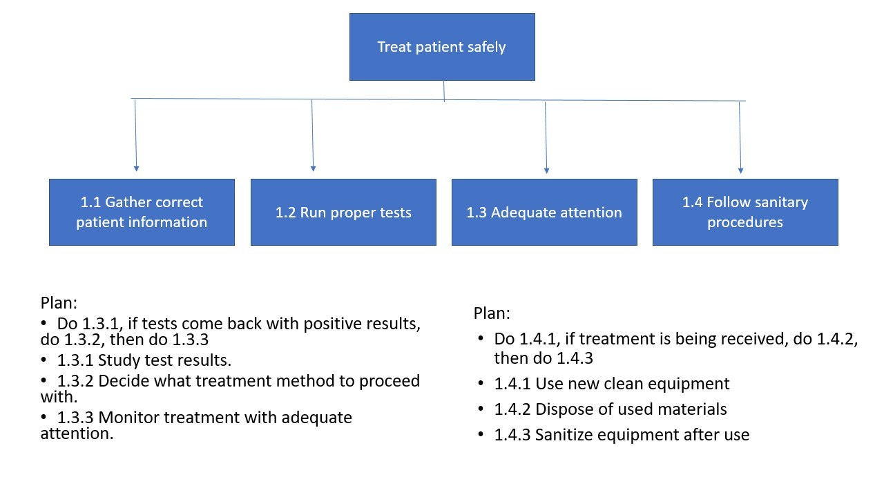

**Tabular Task Analysis (TTA) Table**

|  |  |  |  |  |  |
| --- | --- | --- | --- | --- | --- |
| No. | Action | Cues | Feedback | Possible Errors | Comments |
| 1. | **Gather Correct Patient Information**  PIF:  External: Poor organization of patient files  Internal:  Stressor: Busy / Late night hours | Checking on newly admitted patient  Checking on existing patient | Correct patient information for best possible treatment | Wrong patient information leading to wrong treatment plan | Double check to ensure proper patient information |
| 2. | **Run Proper Tests**  PIF:  External: Multiple test options  Internal: Amount of training, experience.  Stressor: Time and severity of patient condition | Review Patient symptoms  Book appropriate tests | Ensures the tests ran are the correct ones in term of patient diagnosis | Wrong test booked  Forget to book test | Only the proper tests were ran and in timely manner |
| 3. | **Adequate Patient Check-Up**  PIF:  External:  Internal: Passionate staff  Stressor: Broken patient call buttons | Procedures in place for checking in on patients every few hours.  Patient Call Light is on asking for assistance. | Care was provided when the patient requested it or by hospital policy. | Patient Call light was ignored.  Nurse forgets to go to all the assigned rooms for checkups. | Ensures patients are happy and feeling cared for |
| 4. | **Follow Proper Sanitary Procedures**  PIF:  External: Facility doesn’t have written procedures  Internal: Proper training  Stressor: Lazy staff, Time | Use of medical equipment  Finding old/used equipment left out  Room cleaning prior to new patient | Prevents cross contamination and spreading of illness | Accidental infection from leaving used equipment out  Forget to clean room before new patient | Important for keeping illnesses and injuries contained |